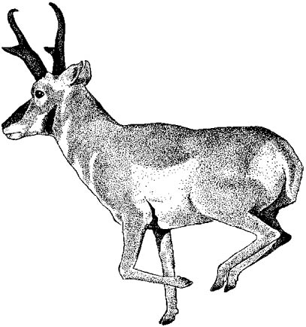

Hunter and Gatherer Program

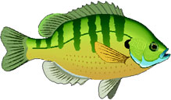
Hunter Medicine Pouch - Did you know the first pocket ever invented was made by hunters? It hangs from your neck and carries arrowheads and other special “medicine”. You will make this bag and leave with your own arrowhead stored safely inside.

Castaway Fishing- Learn how people the world over catch their dinner. All you need is a hook, string and a backyard worm. You will take home your own fishing rod ready for action.

Wild plant harvest- Explore nature’s grocery store. You will learn to identify wild plants found in your own yard and neighborhood. Find plants that smell great. Make your own plant collection.

Animals Tracks- Identify and follow the footprints of wild animals. Make your own plaster track copy. Make a foot print stamp so you can make tracks
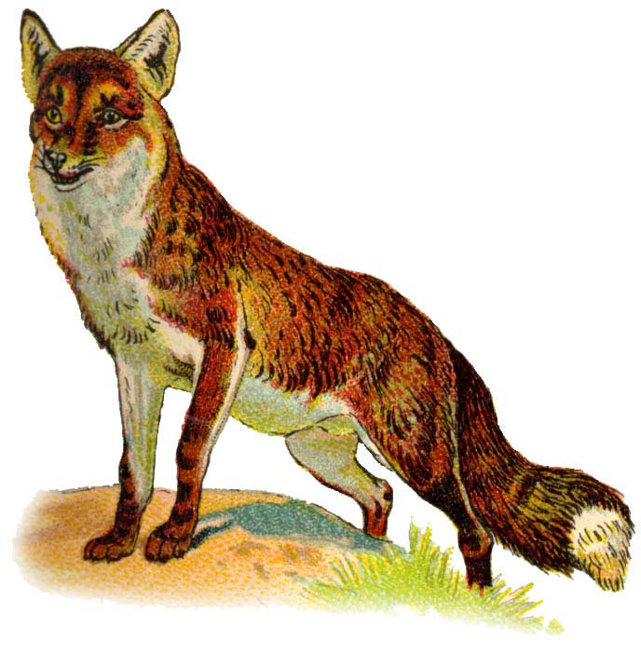
Hunter Games- Be sneaky like a fox. Discover and play the same games that made young Indian children strong, swift and good hunters. You will make your own game to take home.

Be a Survivor- Learn the basics of how to stay alive if lost: how to make warm shelter, find safe drinking water, gather food in your own yard and neighborhood and see how fire is made with “sticks”. You will make your own survival kit.

Hunter and Gatherer Registration Form
6 week course (90 min. Sessions)-$89.
School:_________________________________ Teacher &Grade:________________________
Child’s Name:__________________________ Parent(s):_______________________________

Address:______________________________________________________________________
e-mail:_______________________ Phone:(H)___________________(O)__________________
Make Checks payable to:_________________________________________________________
Send Check to:_________________________________________________________________
□ My Child has permission to remain after school □ My child will go to aftercare
□ My Child will be picked up after class by__________________________________________
Health Considerations:___________________________________________________________
Parent’s Signature:________________________________________Date:__________________

